App Plan and Prototype

DEV104 Design and Develop an iOS App Final Project

Kos Grillis

# App Vision

**Name**: Groggery  
**Is a**: Way to find and discover cocktail recipes  
**For**: People of legal drinking age  
**Who**: Consider themselves cocktail connoisseurs.   
  
Groggery will provide a convenient and easy-to-use interface for users to find and discover cocktail recipes.

# User Persona

## Demographics

Groggery will be targeted at adult consumers (16/18+ depending on local laws) who drink alcohol (in the form of cocktails) occasionally or often.

## Frustrations/Likelihood of engagement

* Users do not drink cocktails often (instead wine or beer). They would like to try some cocktails but don’t know any. They wish for an easy way to discover (and remember) cocktails that they will enjoy.
* Users know and love a small set of cocktails which they order often. They want to branch out and try new cocktails, but they don’t know how. They wished for a way to discover similar cocktails to their already known tastes.

# MVP Feature Set

* Search for cocktail recipes by name or ingredients; display search results as a list including cocktail name and image.
* Interact with search results via tap gesture; displaying more detailed cocktail recipe information including name, ingredients, image, and instructions.
* Save cocktail recipes as a “favourite” to device memory
* Display saved/favourite cocktail recipes as a grid including cocktail name, image and brief details.

## Stretch features

* Allow the in-app experience to be customized via a dedicated settings interface.

# Wireframes and prototype

## Workflow

App workflow will consist of a combination of tab bar navigation and hierarchical presentation.

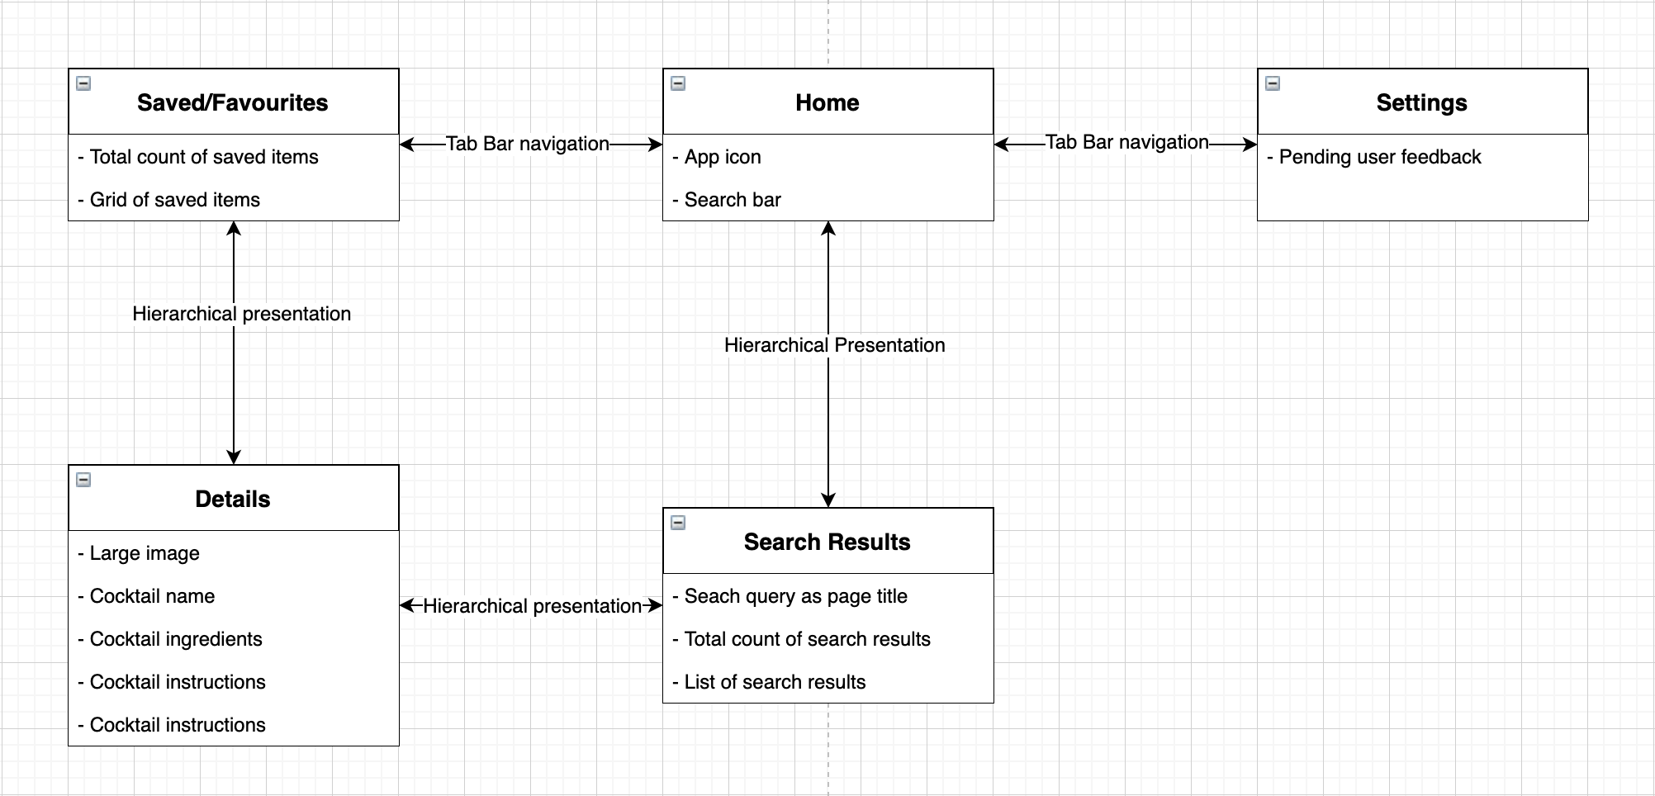

## Wireframes

* Green hands representing tap gestures
* Green arrows representing storyboard segues

# User testing

3 user interviews were conducted. In each case, the participant was presented with the above wireframes and asked how they would go about searching for a cocktail, as well as asked about their general thoughts on the app and its workflow.

|  |  |  |
| --- | --- | --- |
| Participant | Participant comments | My comments |
| * Jake * Age 26 * Drinks occasionally * Legally blind (wears very thick glasses) * Works in marketing | * Found the workflow logical and easy to follow. * Noticed that the designs positioned the favourite star on top of the cocktail image. Suggested to not overlay them as people with his disability will struggle to notice the button depending on the primary color of the image. | * Will ensure that the favourite button is positioned in a location with sufficient contrast. |
| * Martina * Age 32. * Drinks occasionally * Minimal cocktail knowledge. * Language teacher | * Overall successful. First thought was to search “Gin” because she knew it was an ingredient in her favourite cocktail. * Mentioned a distinct lack of “discovery” and that the app relies on the user already knowing what they want. | * It’s true that the MVP of the app does not include many discovery features. Future versions could include features like: * Popular cocktails * I’m feeling lucky * Using tags to find similar cocktails * Suggesting cocktails with similar ingredients in the “details” screen. |
| * Eli * Age 32. * Drinks often. * Is a bartender. | * Feedback overall positive but said they would not use an app like this (already an expert). * Imagined that customers in his bar would attempt to show him cocktails from the app on their phone. Suggested that the list of ingredients is as close as possible to the top of the screen so they he wouldn’t have to touch/scroll their phone. | * Ingredients will be positioned directly under the heading in the “details” screen. |